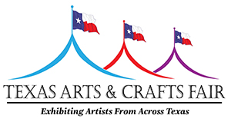
www.txartsandcraftsfair.com

The Texas Arts & Crafts Fair will be held Sept. 25-26, 2021 on the grounds of the Hill Country Arts Foundation in Ingram, Texas.
The fair will feature food vendors along the perimeter of the paved, main parking area, surrounding a tent with tables and chairs. The Texas Arts & Crafts Fair reserves the right to all beer and wine sales.
Early bird cost for a vendor-supplied truck, trailer or tent is $300, and includes electricity. After Aug. 1, the price increases to $350.

If you want to be considered, please complete this application and return it to wgcash@hcaf.com

Food booth name: _________________________________________________________________

Contact name: ____________________________________________________________________

Mailing address: ___________________________________________________________________

Telephone: ________________CELL NUMBER: __________________________________________

E-mail address: (Required):__________________________________________________________

Restaurant name and address (if applicable: ________________________________________________________________________________

Please describe food(s) to be sold and price range:

Dimensions of truck, trailer or tent, length, width, height: _________________________________
Please indicate which side your food truck sells from: passenger side ( ) driver side ( )

Space is limited.
Food vendors’ food type will be exclusive based on first-come, first-served upon acceptance.
Electricity is available at no charge. Space assignments and set-up instructions will be emailed by Sept. 14, 2020.
Do not send payment with this application. Upon acceptance, we will send you an invoice and instructions for payment.

Submit this application to:
wgcash@hcaf.com

• All food vendors must provide certificate of insurance and comply with county health food certifications.

